Is Flat Tax a Good Way to Restore Economy?

Lanxiao Bai

AQF(11AM), Instructor: Zheng Zhang

Featured Article: *Ted Cruz Is Right: His Tax Plan Would Supercharge GDP Growth*

Tim Worstall, Forbes

Date: April 16, 2016

**Introduction**

2016 is a US presidential election year, and during the long progress of the presidential campaign, dozens of presidential candidates presented their policies in various aspects. Among all their plans, economic policy is one of the most eye-catching topic that people care about. In the article published online on Forbes, Tim Worstall discussed the fiscal policy one of the Republican candidate, Ted Cruz, in this article.

Since taxation will always cause deadweight loss in the market and as a result resulted in a burden. There is indeed a order of preferable tax. As the author said, " In order, transactions are worst, then corporate and capital taxation, then upon incomes, next consumption and then finally land value taxation. " As a result, Ted Cruz's plan is worthy praising somehow since it " moves us from corporate taxation to consumption: two steps along that list." And as a result, that will make us all marginally richer.

But the author implied that he did not have as much confidence and doubt the scale of the increase. Since the economy of the United States is near full capacity, fiscal stimulus at that point just isn’t the thing to be donw, because it doesn’t turn up as an increase in real GDP growth it turns up as an increase in inflation. It is debatable how much such tax cuts and similar policy can lead to sustainable growth in real GDP.

**Theory Review and Analysis**

Besides being a kind of plan to simplify the over-complicated tax system and make taxpayers have easier way to calculate the tax they need to pay instead of filling tons of forms requested by IRS, the flat tax system not just makes the business tax a marginal constant. It is also a policy aiming at cut government spending and balance the budget deficit as well as a expansionary fiscal policy targeting stimulate the growth of economy by relieving taxpayers from the burden of tax to promote expenditure and to free business owners from high progressive tax, so that they can invest more in the market and as a result create jobs.

According to the *Laffer Curve* (Figure 1), increase of tax does not always produce an increase in revenue. Instead, when taxation is over a certain threshold, the increase of tax will reduce it conversely. As a result, if it's believable that the current tax scale is harmful to the economy it is a great idea to cut it down.

As the tax was cut down, people will have stronger ability to purchase or undertake investment and as a result make real GDP increase. When more money goes into the market and the fluidity of currency increase, the market would become prosperous again.

As it is well known in microeconomy theory, any kind of tax or regulation will block part of the economy and stop transaction and cause deadweight loss in the market and kill jobs. Such great plan that tries to eliminate all the burdens in the society. Just as monetarism theory and fiscal conservative economists explain, the only way for the economy to revive is government to step backwards and let the market balance itself and reach its equilibrium.

Since 2008, American people are struggling because of recession and massive unemployment. If the plan above works, according to the *Short-run Phillips Curve* (Figure 3),an increase in job offers can be expected. However, what need to be noticed is that such unemployment is not only caused by the recession of economy. Foreign competition and challenges from China, Japan, Korea, Mexico and many other countries are the killer of jobs as well. Although increase foreign competition shifts the PP curve to the right, if American workers and industry were beaten down, the consequence would be disastrous.

However, although Worstall acknowledged that this flat tax system is a good idea, but will fail to do that job, "the effects won’t be large enough". Again, this claim could be possible to point out the reality as well. Just look at Figure 1 again, if the economy is already near its full capacity where the slope is relatively small. Such decrease in tax would not be large enough to reach the goal that Senator Cruz promised and the nominal GDP will grow instead of real GDP.

**Personal Opinion and Conclusion**

In a highly divided political system, Ted Cruz's fiscal policy is determined to be controversial but also really ambitious. His plan of entirely getting rid of the used complicated system sounds attractive especially to those who are already bothered by the tome of taxation laws.

Though this is the case, what's even more important and is more likely to change the status quo is his tax cut plan, which is a plan, though details may be different, that many conservatives think will work to help with reviving the economy of this great nation and benefit the people who are struggling because of low income, inflation and unemployment due to the recession and international competition and challenges surged by the growth of newly developed country. People deserve to care about their well-being and ask the leadership to bring back their jobs back that have escaped from this nation.

As a fiscal conservative, I agree with the author's opinion that it is beneficial to cut the income tax and business tax, whatever its essence is. First of all, although tax itself plays a role of redistributing social wealth and promote social equality and justice, according to both microeconomic and macroeconomic principle, it is a burden to the growth of the market and economy of a country. In microeconomic theory, the existence of tax will cause deadweight loss and decrease the efficiency of the market. In the macroeconomic theory, increase in tax has an effect of decreasing aggregate expenditure as well as GDP.

Actually, this kind of plan is not just an ambiguous dream to please voters, it has a successful experience in the past that turned United States' economy to a positive direction. During the term of President Ronald Reagan, massive tax cut and deregulation acts was executed, which controlled the serious inflation and decreased the unemployment and increase social wealth of all social and economic classes. It is a pity that social wealth was not equally increase, but this supply side stimulus truly worked, so it may be a successful model used to predict the effects of Cruz's policy.

However, the author is not as confident to think this plan will work, which is inconsistent with what we've learnt so far. But since there're so many different ideas in economics, it's still hard to say how much this prediction of the author can be correct. After all, when President Reagan was still in primary election, his economic policy was even criticized by George H. W. Bush to be Hoodoo ecomonics, but it just worked so fine and successfully made America prosperous again and finally defeated the Soviet Union and ended the Cold War.

One more thing that needs to be concerned is the budget deficit. Just like what macroeconomic theory told us, tax cut sometimes can increase tax revenue since business owners can gain more benenit and generate more wealth in the society. However, it could result in massive budget deficit as well just as Reagan and Obama did in their term. In this case, I agree with those libertarian politicians. Sometimes it can be a good stratege to bring some money in order to create more, but it is even more important to reach the balance. Generally speaking, a sustainable developement requires the governemnt to spend as much as they have. This leads to the topic of government spending. The government should spend less, but in order to reach identical or even better effect, it needs to spend well. Just like fuels, you'll need to put it into the tank in order to start driving the car. Though it is irrefutable that social welfare in some extent is necessary, I am never a fan of it. Instead of taxing the rich to subsidize the poor, those capital will have better effects if they are invested into education, technology and small business in order to make young people find a way to feed themselves and their families, improve people's productivity and generate more jobs in the labor market.

**Appendix**：

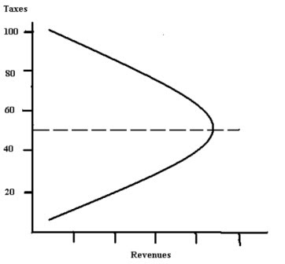

Figure 1 Laffer Curve

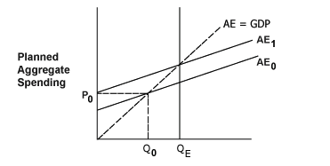

Figure 2 Aggregate Expenditure

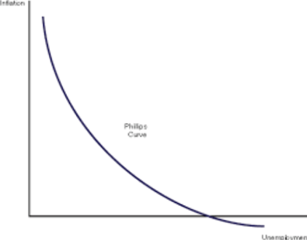

Figure 3 Short-run Phillips Curve